LOHANA SCHOOLS
TOP CLASS REVISION WORK ACTIVITY TWO: 2020
Learning Area 4 – Mathematics
My name is …………………………………………………..
I am in Top class ……………………………………………..
Write the next number.
1 2 _______
2 _______
3 4 _______
4 5 6 _______
7 8 _______
9 _______
TOP CLASS REVISION WORK ACTIVITY TWO: 2020
Learning Area 5 - English
My name is …………………..…………………………
I am in Top class ………………….……………………
Fill in the missing letters.
 | 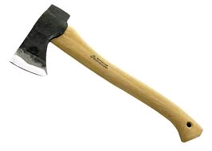 | 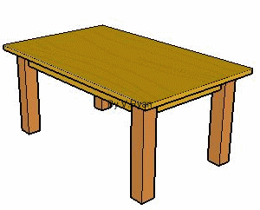
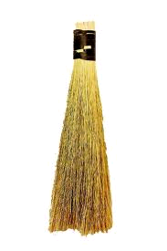  tr___ ___ | a___e | t___bl___
 |  | 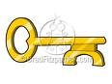
br___ ___m | on___ ___n | k___y
l___af | k___t___ | c___p

TOP CLASS REVISION WORK ACTIVITY TWO: 2020
Learning Area 2 – Social development
My name is …………………………………………………..
I am in Top class ……………………………………………..
Draw people at home.
father | mother
sister | brother
baby

TOP CLASS REVISION WORK ACTIVITY TWO: 2020
Learning Area 5 - Reading
My name is …………………………………………………..
I am in Top class ……………………………………………..
Join sounds and make words.
a – t ______________ p – a – d
i – n ______________ t – i – p _____________
a – n ______________ f – a – n _____________
s – i – n ______________ f – a – t _____________
p – i – n______________ t – a – p _____________
p – i – t ______________ n – i – p _____________
s – a – t ______________ a – s _____________

